James S. Evans Elementary School

Physical Education Syllabus

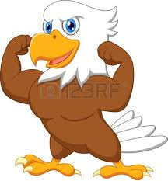

Course Description
Areas of study (See Elementary District Syllabi/Course Handbook pg. 44)

Textbook and Other Resources
Graham, G., Holt-Hale, S A.C., & Parker M. (2003) Children moving: A reflective approach to teaching physical education (6th ed.) Mountain View, CA: Mayfield ld. press.

Classroom Expectations
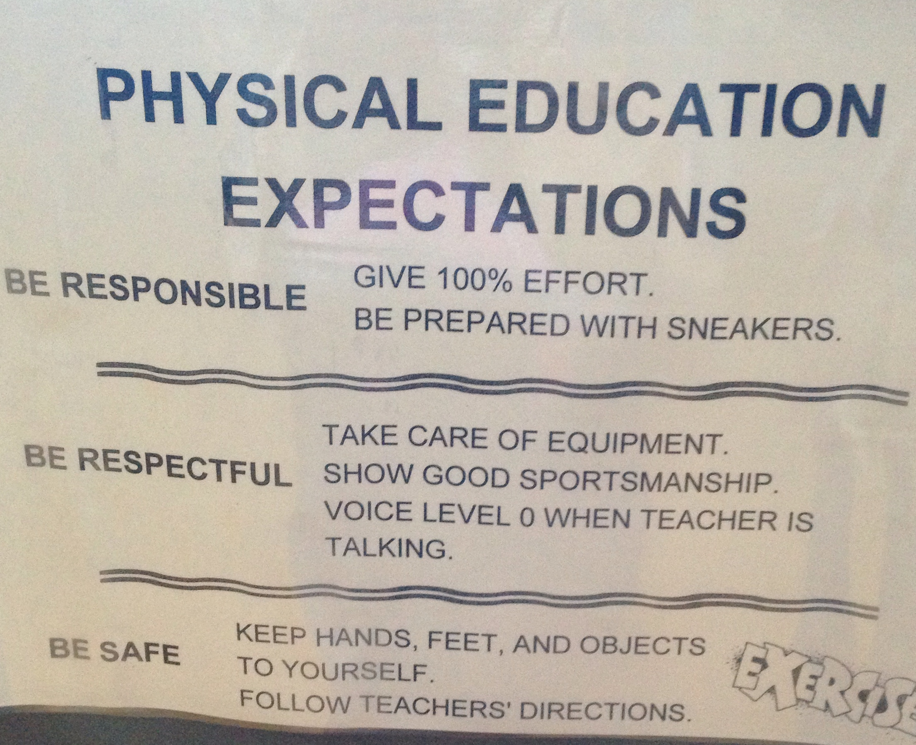
Activities unique to this class
Various team sports (soccer, volleyball, etc.) as well as individual sports (tennis, etc.).
5-6th grades also participate team building activities that incorporate cooperative games (Omnikin).

Recommended/required materials
Sneakers and comfortable clothes

Grading Procedures
Students are evaluated on the quality of participation (effort and attitude), the development and improvement of skills, knowledge of material taught, as well as interpersonal skills
Teacher Contact Information
James S. Evans Elementary, 747 Old Route 9, Wappingers Falls, NY 12590
(845) 298-5240 jon.wurster@wcsdny.org

